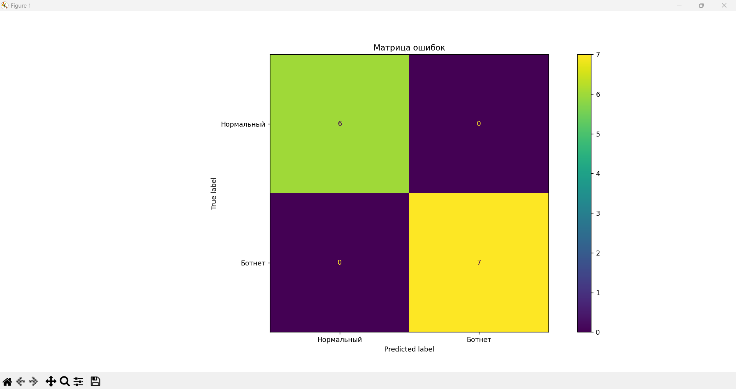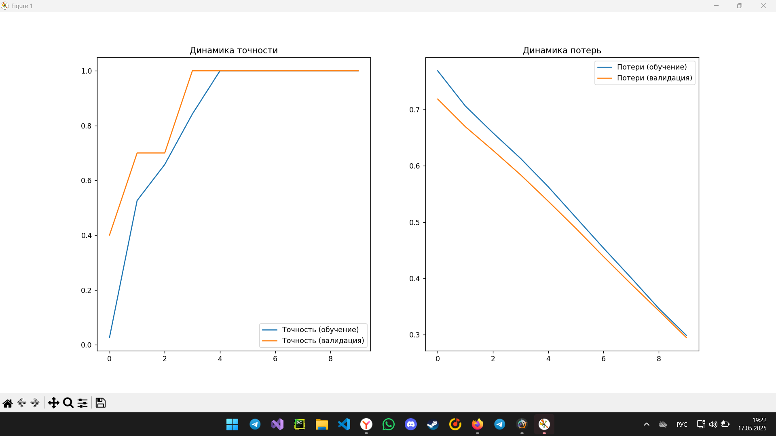

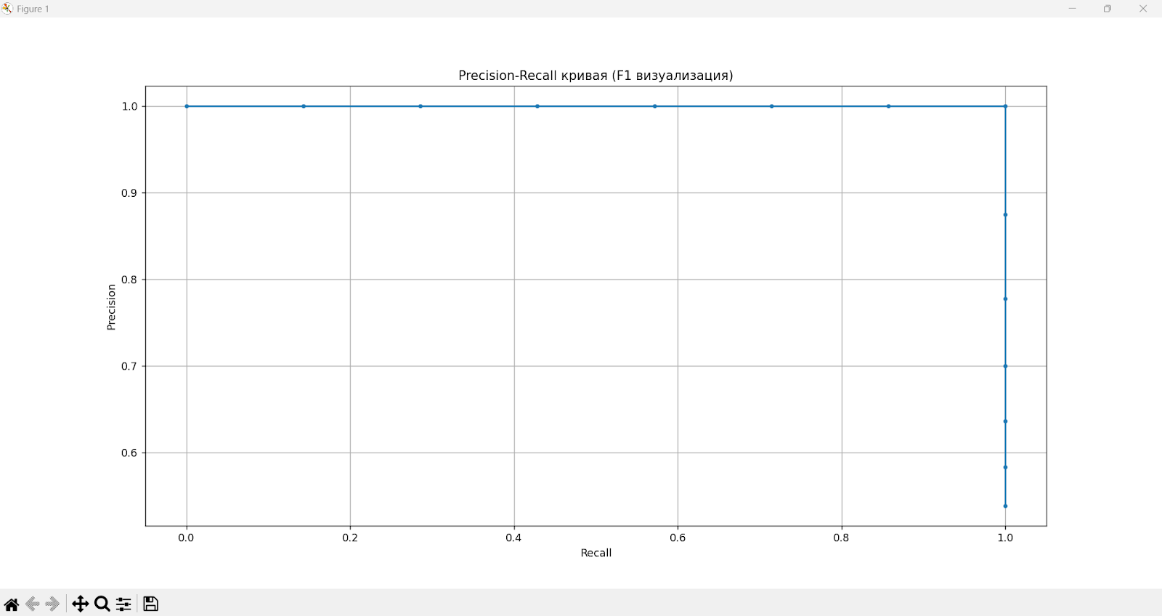

(botnet_env) PS D:\botnet_project\src> python .\botnet_detector.py

2025-05-19 22:01:32.868802: I tensorflow/core/util/port.cc:113] oneDNN custom operations are on. You may see slightly different numerical results due to floating-point round-off errors from different computation orders. To turn them off, set the environment variable `TF_ENABLE_ONEDNN_OPTS=0`.

WARNING:tensorflow:From D:\botnet_env\Lib\site-packages\keras\src\losses.py:2976: The name tf.losses.sparse_softmax_cross_entropy is deprecated. Please use tf.compat.v1.losses.sparse_softmax_cross_entropy instead.

INFO:__main__:Загрузка данных...

INFO:__main__:Обработка botnet.pcap (метка: 1)

INFO:__main__:Обработка normal.pcap (метка: 0)

INFO:__main__:Создание модели...

WARNING:tensorflow:From D:\botnet_env\Lib\site-packages\keras\src\layers\rnn\lstm.py:148: The name tf.executing_eagerly_outside_functions is deprecated. Please use tf.compat.v1.executing_eagerly_outside_functions instead.

WARNING:tensorflow:From D:\botnet_env\Lib\site-packages\keras\src\layers\rnn\lstm.py:148: The name tf.executing_eagerly_outside_functions is deprecated. Please use tf.compat.v1.executing_eagerly_outside_functions instead.

2025-05-19 22:03:51.328832: I tensorflow/core/platform/cpu_feature_guard.cc:182] This TensorFlow binary is optimized to use available CPU instructions in performance-critical operations.

To enable the following instructions: SSE SSE2 SSE3 SSE4.1 SSE4.2 AVX2 AVX_VNNI FMA, in other operations, rebuild TensorFlow with the appropriate compiler flags.

Model: "sequential"

_________________________________________________________________

Layer (type) Output Shape Param #

=================================================================

LSTM1 (LSTM) (None, 30, 64) 18432

dropout (Dropout) (None, 30, 64) 0

LSTM2 (LSTM) (None, 32) 12416

Dense1 (Dense) (None, 16) 528

Output (Dense) (None, 1) 17

=================================================================

Total params: 31393 (122.63 KB)

Trainable params: 31393 (122.63 KB)

Non-trainable params: 0 (0.00 Byte)

_________________________________________________________________

INFO:__main__:Обучение модели...

Epoch 1/10

WARNING:tensorflow:From D:\botnet_env\Lib\site-packages\keras\src\utils\tf_utils.py:492: The name tf.ragged.RaggedTensorValue is deprecated. Please use tf.compat.v1.ragged.RaggedTensorValue instead.

WARNING:tensorflow:From D:\botnet_env\Lib\site-packages\keras\src\utils\tf_utils.py:492: The name tf.ragged.RaggedTensorValue is deprecated. Please use tf.compat.v1.ragged.RaggedTensorValue instead.

WARNING:tensorflow:From D:\botnet_env\Lib\site-packages\keras\src\engine\base_layer_utils.py:384: The name tf.executing_eagerly_outside_functions is deprecated. Please use tf.compat.v1.executing_eagerly_outside_functions instead.

WARNING:tensorflow:From D:\botnet_env\Lib\site-packages\keras\src\engine\base_layer_utils.py:384: The name tf.executing_eagerly_outside_functions is deprecated. Please use tf.compat.v1.executing_eagerly_outside_functions instead.

2/2 [==============================] - 3s 608ms/step - loss: 0.6697 - accuracy: 0.7368 - precision: 0.7273 - recall: 0.8000 - val_loss: 0.6135 - val_accuracy: 1.0000 - val_precision: 1.0000 - val_recall: 1.0000

Epoch 2/10

2/2 [==============================] - 0s 32ms/step - loss: 0.6187 - accuracy: 0.9737 - precision: 1.0000 - recall: 0.9500 - val_loss: 0.5616 - val_accuracy: 1.0000 - val_precision: 1.0000 - val_recall: 1.0000

Epoch 3/10

2/2 [==============================] - 0s 32ms/step - loss: 0.5684 - accuracy: 1.0000 - precision: 1.0000 - recall: 1.0000 - val_loss: 0.5040 - val_accuracy: 1.0000 - val_precision: 1.0000 - val_recall: 1.0000

Epoch 4/10

2/2 [==============================] - 0s 30ms/step - loss: 0.5161 - accuracy: 1.0000 - precision: 1.0000 - recall: 1.0000 - val_loss: 0.4440 - val_accuracy: 1.0000 - val_precision: 1.0000 - val_recall: 1.0000

Epoch 5/10

2/2 [==============================] - 0s 33ms/step - loss: 0.4563 - accuracy: 1.0000 - precision: 1.0000 - recall: 1.0000 - val_loss: 0.3817 - val_accuracy: 1.0000 - val_precision: 1.0000 - val_recall: 1.0000

Epoch 6/10

2/2 [==============================] - 0s 31ms/step - loss: 0.3987 - accuracy: 1.0000 - precision: 1.0000 - recall: 1.0000 - val_loss: 0.3209 - val_accuracy: 1.0000 - val_precision: 1.0000 - val_recall: 1.0000

Epoch 7/10

2/2 [==============================] - 0s 34ms/step - loss: 0.3399 - accuracy: 1.0000 - precision: 1.0000 - recall: 1.0000 - val_loss: 0.2658 - val_accuracy: 1.0000 - val_precision: 1.0000 - val_recall: 1.0000

Epoch 8/10

2/2 [==============================] - 0s 33ms/step - loss: 0.2853 - accuracy: 1.0000 - precision: 1.0000 - recall: 1.0000 - val_loss: 0.2178 - val_accuracy: 1.0000 - val_precision: 1.0000 - val_recall: 1.0000

Epoch 9/10

2/2 [==============================] - 0s 32ms/step - loss: 0.2347 - accuracy: 1.0000 - precision: 1.0000 - recall: 1.0000 - val_loss: 0.1774 - val_accuracy: 1.0000 - val_precision: 1.0000 - val_recall: 1.0000

Epoch 10/10

2/2 [==============================] - 0s 34ms/step - loss: 0.1900 - accuracy: 1.0000 - precision: 1.0000 - recall: 1.0000 - val_loss: 0.1434 - val_accuracy: 1.0000 - val_precision: 1.0000 - val_recall: 1.0000

INFO:__main__:Оценка модели...

1/1 [==============================] - 0s 430ms/step

Результаты:

Точность: 100.00%

Precision: 100.00%

Recall: 100.00%

F1-мера: 100.00%

1/1 [==============================] - 0s 17ms/step

D:\botnet_env\Lib\site-packages\keras\src\engine\training.py:3103: UserWarning: You are saving your model as an HDF5 file via `model.save()`. This file format is considered legacy. We recommend using instead the native Keras format, e.g. `model.save('my_model.keras')`.

saving_api.save_model(

INFO:__main__:Модель сохранена в botnet_model.h5